Word document Preliminary Analysis

Yasmin Roustaei

18 May 2021

## Warning: package 'readxl' was built under R version 3.6.3

getwd()

## [1] "C:/Users/Yasmin Roustaei/Desktop"

[1] We hypothesise that allelic richness of Eulamprus leuraensis populations will increase with increasing elevation. We hypothesise that expected heterozygosity and observed heterozygosity of Eulamprus leuraensis populations will increase with increasing elevation.

[2] Dependent variables-allelic richness, observe heterozygosity, and expected heterozygosity. Independent variables-elevation (500, 600, 700, 800, 900, 1000, 1100 metres).

[3] A linear regression will be used to assess the relationship between elevation and genetic diversity (allelic richness, observed heterozygosity, and expected heterozygosity). The statistical null hypothesis is that the linear relationship between Y (allelic richness, observed heterozygosity, and expected heterozygosity) is equal to 0. The alternative hypothesis is that the linear relationship between Y (allelic richness, observed heterozygosity, and expected heterozygosity) is not equal to 0.

[4] Independence of data within and among samples, X variable is measured without error, Normality of the residuals about the fitted line, m X + b, Homogeneity of variances for residuals about the fitted line m X + b, and Linear relationship

[5]Results The plot illustrates a linear relationship. This suggests that the assumption the relationship is linear is reasonable. It also suggests that there are no unusual data points. It also illustrates that the variation around the estimated regression line is constant suggesting that the assumption of equal variances is reasonable. Assumption of normality also seems reasonable as values follow a reasonably straight line (Figure 2).

There is a significant relationship between the elevation of the mountain and allelic richness (AR) (Linear regression: Df=1,12, R2=0.59, P=0.0022). Allelic richness increased with increasing elevation (Figure 1). There is also a significant relationship between the elevation and expected heterozygosity (Hs) (Linear regression: Df=1,12, R2=0.54, P=0.0043). Expected heterozygosity increased with increasing elevation. Therefore, I reject the null hypothesis that the linear relationship between allelic richness and expected heterozygosity is equal to 0.

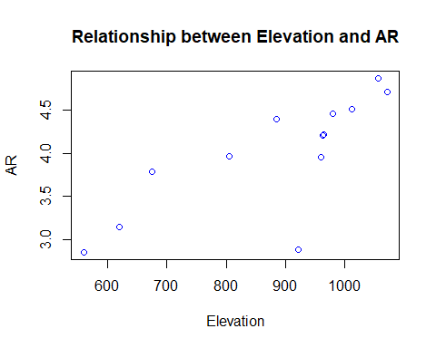

getwd()

## [1] "C:/Users/Yasmin Roustaei/Desktop"

Figure 1: Relationship between mountain elevation and allelic richness (AR)

getwd()

## [1] "C:/Users/Yasmin Roustaei/Desktop"

Figure 2: Normal qqplot for residuals

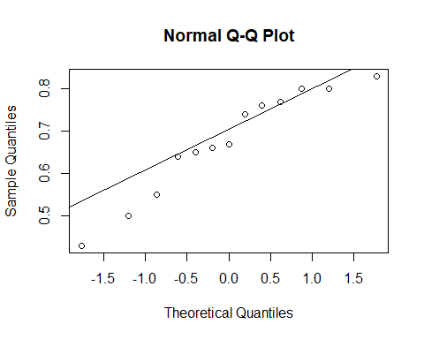

## Population Elevation N(M/F/U) Ho   
## Length:13 Min. : 560.0 Min. : 5.00 Min. :0.4300   
## Class :character 1st Qu.: 805.0 1st Qu.:16.00 1st Qu.:0.6400   
## Mode :character Median : 960.0 Median :19.00 Median :0.6700   
## Mean : 882.7 Mean :18.54 Mean :0.6769   
## 3rd Qu.: 980.0 3rd Qu.:22.00 3rd Qu.:0.7700   
## Max. :1071.0 Max. :40.00 Max. :0.8300   
## Hs AR   
## Min. :0.52 Min. :2.850   
## 1st Qu.:0.67 1st Qu.:3.790   
## Median :0.74 Median :4.210   
## Mean :0.70 Mean :3.996   
## 3rd Qu.:0.78 3rd Qu.:4.460   
## Max. :0.82 Max. :4.870

getwd()

## [1] "C:/Users/Yasmin Roustaei/Desktop"

Observed heterozygosity (Ho), expected heterozygosity (Hs), and allelic richness (AR) of Eulamprus leuraensis populations was higher at higher elevations compared to lower elevations sites (Table 1). Table 1: Elevation of population sites and number of lizard tail samples collected per each population (N), observed heterozygosity (Ho), expected heterozygosity (Hs), and allelic richness (AR).